3.2 The Derivative as a Function

Recall that in the last section we found functions that told us the slope of a tangent line at any point on a curve.

Definition: The derivative of a function f, denoted by is,

if this limit exists.

Note: Geometrically we know that is the slope of the tangent line to the graph of f at the point .

Example 1: If , then find the derivative of f. State the domain of f and the domain of its derivative.

Using the definition, we calculate that:

So, the derivative of the function is . The domain of is all x in and the domain of is all x in . So, the domain for the derivative is slightly smaller than the domain of the function.

Note: Some of you may know some derivative formulas/shortcuts. It is important to understand that if you are ever asked to find the derivative of a function USING ONLY the definition of derivative, you must complete the problem as we did in the above example.

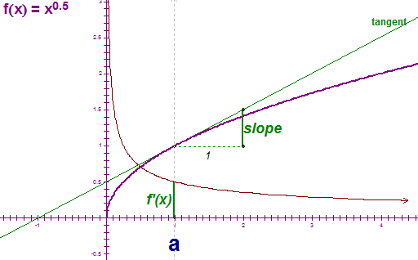
Note: The instructor will do a GSP demonstration to illustrate the geometrical meaning of what was found in the above example. A key part of the demonstration is noting there would have to be a vertical tangent at x=0. A picture of part of the demonstration is at the right..

Example 2: Find if .

Using the definition, we calculate that:

So, the derivative of the function is .

Example 3:
Use the graph given below of the function to sketch a rough graph of .

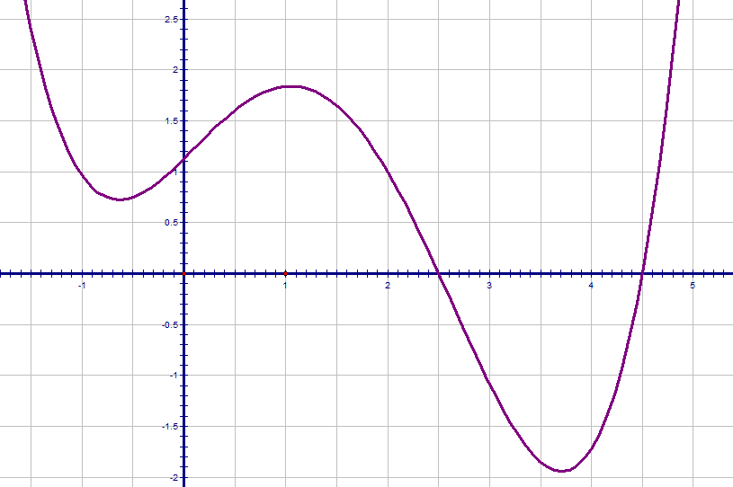
The key to sketching a graph of the derivative is to think about the slope of tangent lines to the graph. In particular, we note that the slopes of tangent lines start negative and increase to 0 at the x value of about -0.6. Then, the slopes of tangent lines are positive and increasing until the x value of about 0, and then the slopes decrease to 0 at about an x value of 1. Then, the slopes of the tangent lines become negative and decrease until an x value of about 2.7. The slopes then increase to 0 at an x value of about 3.6. Finally the slopes continue to increase. Accordingly our picture is:

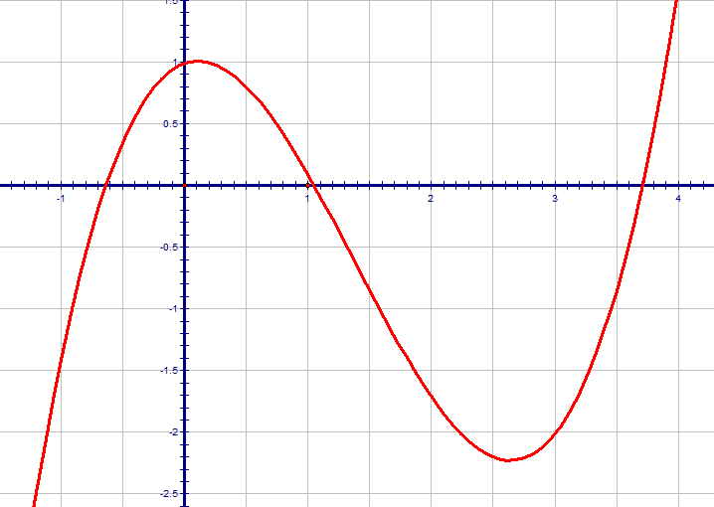

Example 4:
The graph of the function is shown below.
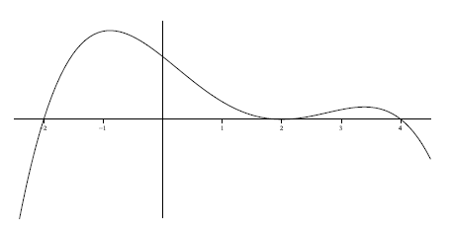

One of the six graphs below is the graph of . Circle the graph of .
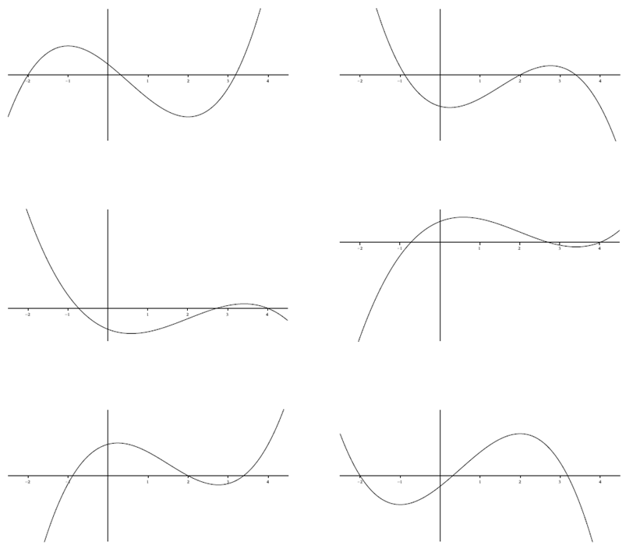

Notation: Somewhat unfortunately, there are many other notations for the derivative of .
In MTH 200 we will use the first five:
Prime notation
Leibniz
notation

Note: The symbol is known as a differential operator, and this specific piece of notation is due to Leibniz.
Prime Notation:
The second derivative of f , , is denoted .
The third derivative of f , , is denoted .
Once we get above the third derivative we use numbers to indicated the number of primes.
In particular, the nth derivative of f is denoted when .

Leibniz Notation:
For Leibniz notation, the second derivative of is denoted: .
In general the nth derivative of is denoted: .

The advantage of using Leibniz Notation is that it shows important information about the derivative being calculated.

Note: We will study the meaning of higher order derivatives in later chapters.

Definition: A function f is differentiable at if exists.

It is differentiable on an open interval if it is differentiable at every number in the interval.

Example 5:
Show that is not differentiable at.

Recall: (from Example 1)

Notice that which is undefined. So f is not differentiable at .

The next theorem gives us a relationship between differentiability and continuity.
Theorem: If is differentiable at a, then is continuous at a.

Proof:
We are given that f is differentiable at a and we need to show that f is continuous at a.
In order to show is continuous at a, we must show .

Since is differentiable at a, we know that exists.
Using the limit laws, we notice:

So, we have that which implies which implies as desired.

Questions to the Class: 1. If a function is discontinuous at a, can it be differentiable at a?
2. If a function is continuous at a must it be differentiable at a?

Answer:
The answer to question 1 is no, and it follows from the theorem since it is the contrapositive of the statement.

The answer to question 2 is no and it is addressed in the next example.

Example 6: Consider. Note that the function is continuous at 0. Is it differentiable at 0?

To find the derivative of at 0, we must analyze the limit: .
We showed in a previous lecture that and .
Hence, DNE, and the function is not differentiable at 0.

Note: The graph of the absolute value function has a sharp corner at 0. This is usually an indication that we lack differentiability. This example shows that the just because a function is continuous at a point does not imply that it will be continuous there.
How a Function can Fail to be Differentiable?
Remember that the derivative is the measure of the slope of the tangent line.
Therefore, if the tangent line has an undefined slope, is not in the domain of the derivative function, or if the graph is discontinuous or has a corner point then the derivative may be undefined.
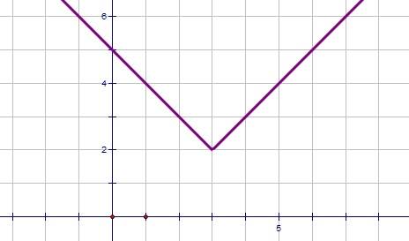
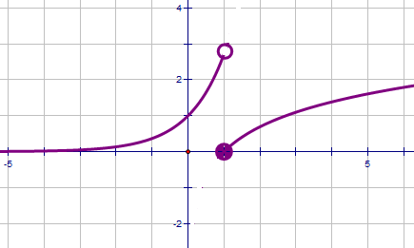
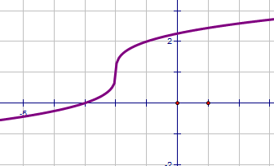
$$a$$
$$a$$
$$a$$

- A vertical tangent line (b) a discontinuity (c) a corner point

Slope is undefined so  does not exist | The curve has no direction at this point so  does not exist | The curve has no direction at this point so  does not exist

Example 7: Suppose that you are told exists.

- Based upon this information, where must f be continuous?

The existence of the limit implies that f is differentiable at 1. By the most recent theorem, this means that f is continuous at 1.

- What does equal?

By the definition of continuity, .

